Trusted Tiny Things User Study

Instructions for Participants
Thank you very much for agreeing to participate in this study. We have developed a mobile app called “Trusted Tiny Things” which is designed to provide information about the capabilities of Internet-connected devices so users can make more informed decisions before interacting with such devices. This technology has recently been deployed in approximately 2300 bus stops in Aberdeen city and Aberdeenshire. We are looking for your help to test and evaluate this novel technology.
Step 1: Install the “Trusted Tiny Things” mobile app. You can locate the app by using the Google Play store on your Android smartphone searching for “trusted tiny things”. If the information about the app correspond to the screenshot below, tap on the INSTALL button to proceed.
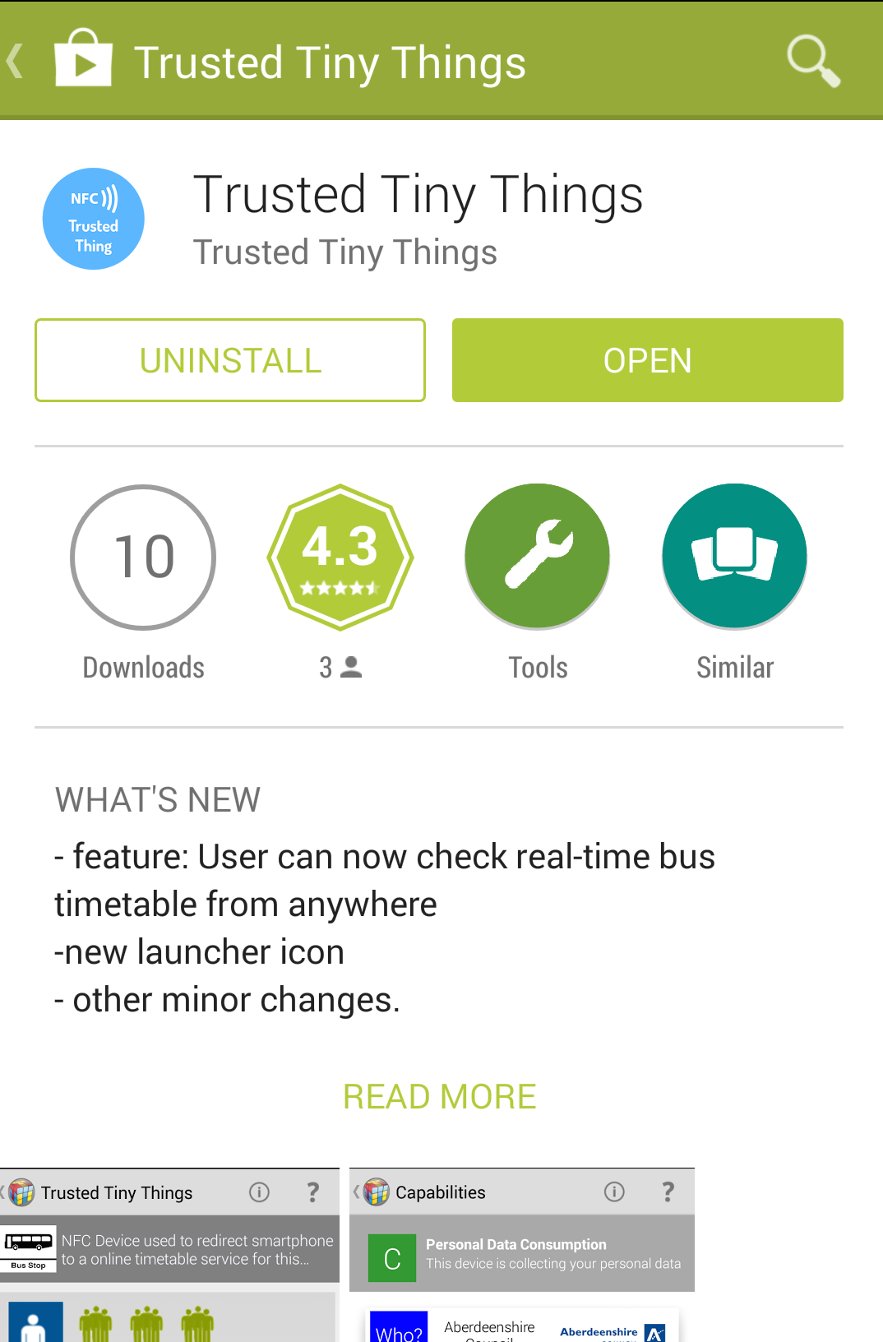
Is the installation was successful, the Trusted Tiny Things icon should appear in your home screen or in you applications screen as illustrated in the screenshot below.
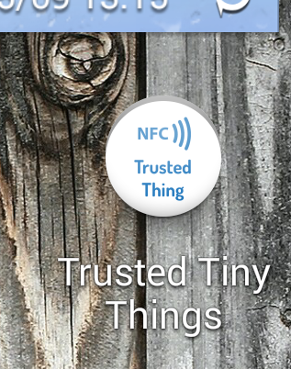
Step 2: Make sure that the NFC reading capabilities are enabled in your smartphone. Please refer to your smartphone user guide for further details.

Step 3: Look for the following tag available at bus stops in Aberdeen city or Aberdeenshire…
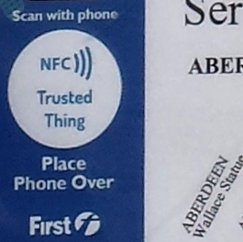
… and scan the tag by placing your smartphone over the white “Trusted Thing” logo.
Normally you should be presented with a web page showing the current bus timetable for that specific bus stop. However, if the Trusted Tiny Things app is installed correctly, you should be presented with information about the device that you have just scanned (NFC tag at bus stop) and the Internet services that you are about to interact with using your smartphone (Bus Timetable Service).
Please note that the Trusted Tiny Things app does not need to be open before you scan an NFC tag.
The top part of the application should look like this:
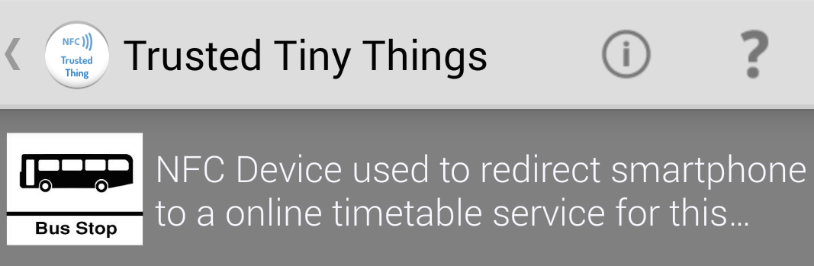

Step 4: Explore the information presented in the Trusted Tiny Things app. You can tap on various areas of the screen to obtain more details about the capability of the device/service, what kind of personal information might be collected and by whom.
Please note that if you tap on the Accept button it will mean that you are happy with what this device/service is capable of and you will be redirected to the bus timetable service. Otherwise, if you tap on the Decline button, you will be prevented from accessing the timetable service.
Step 5: Try to use the app more than once with different bus stops and explore the various functionalities. For example, if you accept a device (in this case a NFC tag of a bus stop), you can assign a nickname to it so it can be accessible later. The devices you have previously accepted are listed in you personal catalogue that is accessible by opening the Trusted Tiny Things app from your home screen.
Step 6: Approximately a week after the beginning of the study you will receive an email invitation to complete an online questionnaire, which will be used to collect your feedback about the mobile app and the Trusted Tiny Things service. After the successful completion of the questionnaire we will make arrangements to issue the travel voucher.

 | Would you like to be rewarded with a travel ticket worth £19.50?
 | Do you own an Android smartphone?
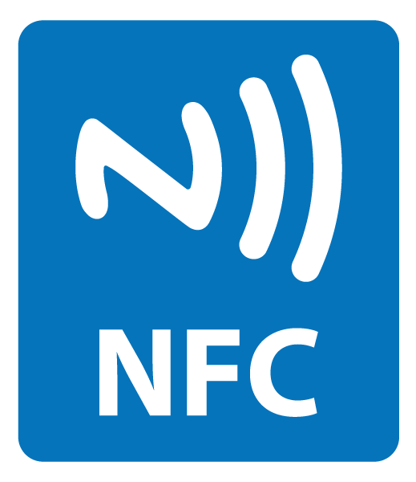 | Can your smartphone read NFC tags?
 | Do you use public transport in Aberdeen?
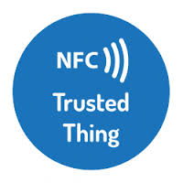 | Would you like to help us to test a brand new mobile app that can help people to understand how internet-connected devices really work?

If the answer to all of the above question is YES please get in touch with Edoardo Pignotti (e.pignotti@abdn.ac.uk).

The Trusted Tiny Things (T³) project is aiming at investigating how some of the challenges inherent in making the Internet of Things (IoT) more transparent and trustworthy to users. The study is conducted by members of the dot.rural Digital Economy Hub at the University of Aberdeen.

Information sheet

The Trusted Tiny Things (T³) project is investigating some of the challenges making the Internet of Things (IoT) more transparent and trustworthy to users. The study is conducted by members of the dot.rural Digital Economy Hub at the University of Aberdeen. The key contact for the T³ project is Dr Edoardo Pignotti (e.pignotti@abdn.ac.uk).
What will you need to do?
Firstly you will be required to install the “Trusted Tiny Things” app in your Android smartphone by downloading it from the Google Play store.
You will be asked to use you smartphone to scan the “Trusted Things” NFC tags available at bus stops in Aberdeen and to review the information about the bus timetable service using our mobile app.
Approximately a week after the beginning of the study you will be invited to complete an online questionnaire which will be used to collect your feedback about the mobile app and the Trusted Tiny Things service.
After the completion of the online questionnaire you will be rewarded with a travel ticket worth £19.50 which allows 10 single journeys on the First Aberdeen network.
Data Protection
The information collected from this experiment will be kept in a secure server and no one outwith the research team will have access to it. Anonymised extracts from the data may be used as the basis for articles or presentations in the future.

Thank you very much for participating.

T³ – User Study

Name of Researcher(s): Edoardo Pignotti and Stanislav Beran

Consent form for participation in research interview
Please complete the form below by ticking the relevant boxes and signing on the line below. You will receive a copy of the completed for your records.

Please Tick Box

1. | I confirm that I have read and understand the information sheet for the above study. I have had the opportunity to consider the information, ask questions and have had these answered satisfactorily. | ☐
2. | I agree to take part in the study described on the information sheet . | ☐
3. | I understand that my participation in this research is voluntary. I can withdraw my consent to collaborate and ask to delete all stored data by contacting a member of the research team. | ☐
4. | I consent to allow the anonymised data from this activity to be used for future publications and other scholarly means of disseminating the findings from the research project. I understand that any direct quotations will not be directly attributed to me. | ☐
5. | I understand that the data collected during the activity will be stored on a server provided by the University of Aberdeen and that third parties will not have access to this material. The data will be managed according to the University of Aberdeen Privacy Policy. | ☐
6. | I understand that on completion of the research, researchers may be requested to deposit the anonymised material according to the EPSRC policy framework on research data  (http://www.epsrc.ac.uk/about/standards/researchdata/Pages/policyframework.aspx) to assure public access to publicly held information. | ☐

Name of participant |  | Date |  | Signature
Name of researcher |  | Date |  | Signature

