Tumour imaging by Positron Emission Tomography using fluorinase generated 5-[¹⁸F]fluoro-5-deoxyribose as a novel tracer

Short title 5-[¹⁸F]fluoro-5-deoxyribose as a novel PET tracer

Sergio Dall'Angelo,¹ Nouchali Bandaranayaka,² Albert D. Windhorst,*³ Danielle J. Vugts,³ Dion van der Born,³ Mayca Onega,^{1,2} Lutz F. Schweiger,¹ Matteo Zanda*¹ David O'Hagan*²
¹Institute of Medical Sciences, College of Life Sciences and Medicine, University of Aberdeen, Foresterhill, Aberdeen, AB25 2ZD, UK. E. mail m.zanda@abdn.ac.uk
²EaStChem School of Chemistry and Biomolecular Science Research Centre, University of St Andrews, North Haugh, St Andrews, KY16 9ST, UK. E. mail do1@st-andrews.ac.uk; Phone +44 1334 467176; FAX + 44 1334 463808
³Department of Nuclear Medicine and PET Research, VU University Medical Center, De Boelelaan 1117, 1007 MB, Amsterdam, The Netherlands.E. mail ad.windhorst@vumc.nl

Keywords: Positron emission tomography; fluorine-18; 5-fluoro-5-deoxydeoxyribose; fluorinase; biotransformation; tumour mice models;
Abstract
Introduction: 5-[¹⁸F]Fluoro-5-deoxyribose ([¹⁸F]FDR) 3 was prepared as a novel monosaccharide radiotracer in a two-step synthesis using the fluorinase, a C-F bond forming enzyme, and a nucleoside hydrolase. The resulting [¹⁸F]FDR 3 was then explored as a radiotracer for imaging tumours (A431 human epithelial carcinoma) by positron emission tomography in a mice model.
Methods: 5-[¹⁸F]Fluoro-5-deoxyribose ([¹⁸F]FDR) 3, was prepared by incubating S-adenosyl-L-methionine (SAM) and [¹⁸F]fluoride with the fluorinase enzyme, and then incubating the product of this reaction, [¹⁸F]-5'-fluoro-5'-deoxadenosine ([¹⁸F]FDA) 2, with an adenosine hydrolase to generate [¹⁸F]FDR 3. The enzymes were freeze-dried and were used on demand by dissolution in buffer solution. The resulting [¹⁸F]FDR 3 was then administered to four mice that had tumours induced from the A431 human epithelial carcinoma cell line.
Results: The tumour (A431 human epithelial carcinoma) bearing mice were successfully imaged with [¹⁸F]FDR 3. The radiotracer displayed good tumour imaging resolution. A direct comparison of the uptake and efflux of [¹⁸F]FDR 3 with 2-[¹⁸F]fluoro-2-deoxyglucose ([¹⁸F]FDG) was made, revealing comparative tumour uptake and imaging potential over the first 10-20 min. The study revealed however that [¹⁸F]FDR 3 does not accumulate in the tumour as efficiently as [¹⁸F]FDG over longer time periods.
Conclusions: [¹⁸F]FDR 3 can be rapidly synthesised in a two enzyme protocol and used to image tumours in small animal models.
1. Introduction
Positron emission tomography (PET) has emerged as a powerful imaging technique to complement magnetic resonance imaging (MRI), particularly where PET is coupled to computed tomography (CT) [1]. As the global activity in PET research increases, new radiotracers are in demand particularly for diagnosis and monitoring of tumours in oncology [2], neurologicaldisorders [3] and cardiovascular pathologies [4]. Fluorine-18 is particularly attractive for this modality because it is readily generated using a cyclotron and it has a relatively long physical half-life (110 min) compared to ¹¹C (20 min), ¹³N (10 min), ¹⁵O (2 min), the other most common isotopes used to label ligands for PET imaging, not including radiometals. With the rapid expansion in the application of PET in the clinical setting, there is a concomitant demand for novel synthesis methodologies for the incorporation of appropriate radioisotopes, including fluorine-18 into new molecules and the development of new PET ligands [5]. We have developed an enzymatic method for ¹⁸F-C bond formation utilising a fluorination enzyme (fluorinase; 5′-fluoro-5′-deoxyadenosine synthase, 5′-FDAS, E.C. 2.5.1.63) originating from the bacterium Streptomyces cattleya [6, 7]. Enzymology with fluoride ions is extremely rare but this enzyme has the advantage that it can utilise [¹⁸F]fluoride ions in aqueous solution generated directly at the [¹⁸O]water target [8-13]. The [¹⁸F]fluoride does not need to be secured and dried by the ususal ion exchange methodologies because the enzyme functions most efficiently in water. The fluorinase enzyme catalyses the conversion of S-adenosyl-L-methionine (SAM 1) and [¹⁸F]fluoride ion to 5′-[¹⁸F]fluoro-5′-deoxyadenosine ([¹⁸F]FDA) 2 and L-methionine 4 (Scheme 1) [6, 7]. When a nucleoside hydrolase (NH) is added subsequently to the prepared [¹⁸F]FDA 2, then the synthesis of 5-[¹⁸F]fluoro-5-deoxyribose ([¹⁸F]FDR) 3 can be achieved [8]. The objective of this study was to assess if [¹⁸F]FDR 3 can be used as a small radiolabelled monosaccharide to image tumours. For comparison, uptake of 2-[¹⁸F]fluoro-2-deoxyglucose ( [¹⁸F]FDG), the most commonly utilised radiotracer in oncology [14, 15], was co-assessed in the same tumour bearing mice. [¹⁸F]FDR 3 and [¹⁸F]FDG are both low molecular weight monosaccharides and in general they have similar molecular characteristics, however to date [¹⁸F]FDR 3 has never been assessed in vivo at any level.
In order to offer a practical methodology the two enzyme protocol used to prepare [¹⁸F]FDR 3 [9] required the development of user friendly enzyme preparations such that the biotransformation process could be readily transferred and easily used in a radiochemistry laboratory.
[Scheme 1]

2. Methods
2.1 Materials and methods:
L-Amino acid oxidase (L-AAO, EC 1.4.3.2, Crotalus adamanteus, type I, 0.3 unit/mg), S-adenosyl-L-methionine (SAM 1) and solvents were purchased from Sigma-Aldrich Co., UK. All solvents were of High Performance Liquid Chromatography (HPLC) grade or purified and degassed according to standard procedures. Standard samples of FDA 2 and FDR 3 were chemically synthesised following previously reported protocols [16, 17]. Fluorine-18 production was conducted in a CTI RDS-111 cyclotron (CTI/Siemens) or an IBA 18/9 Cyclone and radioactivity was measured using a Capintec well reader (CRC-15R) or a Veenstra 405 (Joure, Netherlands). HPLC analyses were performed on a Shimadzu Co. (Kyoto, Japan) HPLC system equipped with a SPD-M20A Prominence DAD UV detector (Shimadzu, Japan) and NaI radiodetector (Berthold Technologies, Bad Wildbad, Germany) or HPLC system consisting of a Jasco PU-1580 gradient HPLC pump (Ishikawa-cho, Japan), a Rheodyne 7724I injector (IDEX Health & Science, Wertheim-Mondfeld, Germany) with a 20 μL loop, a Jasco UV-2075 Plus UV detector (Ishikawa-cho, Japan) and a NaI radioactivity detector (Raytest, Straubenhardt, Germany). The HPLC system used a Phenomenex Luna C-18(2) analytical column (250 x 4.6 mm, 5 μm, 100 A) equipped with the corresponding guard column. A gradient mobile phase was created using water (100%) at 1 mL/min to reach 25 % acetonitrile by 14min and then back to 100% after 16 min.

2.2 Purification of the fluorinase
The fluorinase enzyme was purified using a modified method from a previously established protocol [6]. E. coli BL21(DE3) cells were transformed with pET28-flA containing the flA fluorinase gene. These cells were incubated for 16 h at 37°C and were then used to inoculate a larger volume of LB media (4L) containing 0.1 g/L of kanamycin. The cultures were then incubated at 37°C until the OD₆₀₀ had reached 0.6. The over-expression cultures were induced by adding isopropylthiogalactoside (IPTG at 0.5mM) and the incubation was continued at 20°C for 16 h. Cells were harvested by centrifugation (Beckman Coulter Inc. Ireland) and resuspended in lytic buffer 20 mM tris(hydroxymethyl)amonimethane (Tris), 150 mM NaCl, 20 mM Imidazole, pH 8) with Roche Complete Protease Inhibitor and deoxyribonuclease (0.1 mg/mL) and then lysed by sonication using Soniprep 150 (MSE (UK) Ltd, London). Following sonication the cell lysate was centrifuged (Beckman Coulter Inc. Ireland) to separate the insoluble cell debris from the soluble fraction and the soluble fraction was collected and applied to a column packed with Ni-NTA resin (Qiagen). Recombinant protein bound to the resin was eluted using a buffer containing Tris-HCl (20 mM ,pH 8), imidazole (400 mM, pH 8.0) and NaCl (0.4M). The eluted protein was concentrated (~2 mL) using a Vivaspin concentrator (Vivascience) and the concentrated protein was subject to gel filtration on a Superdex S-200 (HR16/60) column (PharmaciaBiotech) using fast protein liquid chromatography (FPLC). Tris-HCl buffer (10 mM, pH 7) containing NaCl (30 mM) was used to elute the protein. Finally the purified protein was concentrated using a Vivaspin concentrator (Vivascience) and the protein concentration was measured using a NanoDrop 1000 spectrophotometer (Thermo Fisher Scientific Inc.,USA) using Tris-HCl buffer (10 mM, pH 7) and NaCl (30 mM) as a background solution.

2.3 Purification of the nucleoside hydrolase
The nucleoside hydrolase (NH) enzyme was purified using a modified purification method of a previously established protocol [18, 19]. Overnight cultures of E.coli WK6 cells containing the IAG-NH ORF in pQE-30 were used to inoculate LB containing ampicillin (50 mg/mL). These cultures were incubated at 37°C until the cells reached an OD₆₀₀= 0.6. The cultures were cooled to 28°C and then IPTG (0.5 mM) was added. The cultures were incubated for 16 h at 37°C and the cells were harvested by centrifugation (Beckman Coulter Inc. Ireland). The pellet was then re-suspended in a lysis buffer (10 mM phosphate, 150 mM NaC1, 20 mM Imidazole, pH 7.8) containing Roche Complete Protease Inhibitor and deoxyribonuclease (0.1 mg/mL). The pellet was lysed by sonication using Soniprep 150 (MSE (UK) Ltd, London) and then centrifuged (Beckman Coulter Inc. Ireland). The soluble supernatant was applied on to Ni-NTA resin (Quiagen) packed column. The protein retained by the Ni beads was eluted with (10 mM phosphate buffer, pH 7.8, 150 mM NaCl, 500 mM Imidazole pH 7.8). The protein was then dialysed against a buffer (20 mM 4-2-hydroxyethyl)-1-piperazineethanesulfonic acid (HEPES), 1 mM CaCl₂, 150 mM NaCl, pH 7) at 4°C, and was concentrated (~2 mL). The concentrated protein was then applied through gel filtration to a Superdex S-200 (HR16/60) column (PharmaciaBiotech) using FPLC. HEPES buffer (50 mM HEPES,10 mM NaCl, pH 8) was used to elute the protein from the size exclusion column. Finally the protein was concentrated using aVivaspin concentrator (Vivascience) and protein concentration was measured using a NanoDrop 1000 spectrophotometer (Thermo Fisher Scientific Inc. USA).

2.4 Freeze-drying protocols
The solutions of the purified fluorinase and nucleoside hydrolase enzymes in their eluent buffers were freeze dried on a Christ Alpha 1-2 LD Freeze dryer (Martin Christ GmbH, Osterode am Harz, Germany) at -54°C, 0.27 mbar vacuum for ~15-20 h until complete dryness. The products were amorphous white solids.

2.5 Stability testing of fluorinase
Freeze-dried fluorinase/buffer (1 mg) was incubated with SAM-Cl (final concentration : 0.2 mM), potassium fluoride (final concentration:100 mM) and sodium benzoate (final concentration :2 mM) (as an internal standard) in a total reaction volume of 1 mL made up with sterile water. This reaction was incubated at 37°C and at 30 min intervals an aliquot (140 μL) was removed for HPLC analysis. The reaction was arrested by heating (5 min at 95°C) and the volume centrifuged for 10 min at 13000 rpm (Hettich Mikro 200, Germany). The denatured enzyme pellet was removed and an aliquot (20 μL) of the supernatant was injected onto the HPLC. Both the production of FDA and depletion of SAM could be monitored by UV detection. Reactions were carried out in duplicate.

2.6 Stability testing of nucleoside hydrolase
The freeze dried nucleoside hydrolase/buffer preparation (20mg/mL) was resuspended in water and incubated with FDA (0.5 mg/mL) and with 2-fluoroethanol (1 mM, as an internal standard) in a total reaction volume of 2 mL. At hourly intervals over a 4 h period an aliquot (500 μL) was removed for HPLC analysis and the enzyme was denatured by heating (5 min at 95°C) after 4 h. Subsequently the reaction mixture was centrifuged (10min at 12000 rpm) and an aliquot (400 μL) of the supernatant was diluted with D₂O (300 μL) and transferred to an NMR tube and the reaction products were assessed by ¹⁹F{¹H}-NMR (Bruker 500MHz).

2.7 Preparation of [¹⁸F]FDR
Optimised radiochemical synthesis:
In a typical radiochemical experiment, the freeze-dried fluorinase enzyme (6.5 mg) was incubated with SAM-Cl (10 μL, 10 mM),L-AAO (1 mg) and a solution of [¹⁸F]fluoride (200-350 MBq), to reach a total reaction volume of 600 μL. The reaction was incubated at 37ºC for 20-30 min. An aliquot (~1-5 μL) was diluted in water (49-45 μL), heated (100ºC, 1 min), centrifuged (5 minutes at 12000 rpm) and the supernatent analysed by radio-HPLC (20 μL injection) for analysis of [¹⁸F]fluoride incorporation. This indicated a radiochemical conversion of 98%±1 (n=4) (Figure 2).
The reaction mixture was then heated (100ºC, 2 min) and precipitated protein was centrifuged (13500 rpm; 2 min). The supernatant was not decanted, in order to minimise radiation exposure. A preparation of purified, freeze-dried T. vivax nucleoside hydrolase (NH) (39 mg) was dissolved in water (50 μL) and was added to the supernatant. After the addition of NH, the reaction mixture was incubated for 1 h at 37ºC, and an aliquot was taken for HPLC. The radiochemical conversion for this step was between 75 and 98% (n=4) and the total reaction time from the addition of [¹⁸F]fluoride to [¹⁸F]FDR synthesis was between 100 and 120 minutes. It was not possible to determine the specific activity of the [¹⁸F]FDR since this was below the limit of detection for quantative HPLC analysis.
For imaging studies [¹⁸F]FDR production was performed using a modification to the protocol reported above. This involved a higher level of initial [¹⁸F]fluoride activity (up to 10 GBq) and the reaction was performed in an automated radiochemical system. Thus after heat denaturation/protein precipitation, the reaction mixture was diluted with water (650 μL), loaded on a Sep-Pak Plus C₁₈ cartridge (Waters) and was eluted with water (2.6 mL).
Purification of [¹⁸F]FDR through Solid Phase Extraction (SPE) cartridges was investigated and the best results were achieved with a set of cartridges composed of a CHROMAFIX® PS-Ag Cartridge (MACHEREY-NAGEL, Germany) equilibrated with sterile water (4 mL), a Waters Sep-Pak C18 PLUS Cartridge (Waters Chromatography B.V., Etten-Leur, Netherlands) equilibrated with EtOH (10 mL) and water (10 mL) and a CHROMAFIX®30-PS-HCO₃ cartridge (MACHEREY-NAGEL, Germany) equilibrated with EtOH (1 mL) and sterile water (5 mL). The reaction mixture was diluted with sterile water (700 µL) filtered through a Millex 0.22 µm DLL filter and passed through the cartridge set. The set was eluted (3 x1 mL) with sterile water and each fraction was collected in a different vial. Radiochemical and UV purity were assayed by HPLC and the identity of [¹⁸F]FDR was confirmed by comparison with an nonradioactive reference sample.
A slightly modified procedure took place for the actual imaging studies at the VU University Medical Centre in Amsterdam. Accordingly a solution of freeze-dried fluorinase/buffer (10 mg/mL) and 30mM NaCl was prepared in sterile water (600 µL). L-AAO (1 mg) and a solutionof SAM-Cl (10 mM,10 µL) was added to a glass reactor vessel designed to fit the radiosynthesis system [20]. A [¹⁸F]fluoride solution (600 µL,10 GBq) was added to the reaction mixture and the system maintained at 37ºC for 30 min. The reaction vessel was then heated at 99ºC for 2 min and cooled to 37ºC. A buffered solution of the freeze dried nucleoside hydrolase (39 mg) was added directly to the reaction mixture to afford a final concentration of 60 mg/mL of protein in 50 mM HEPES buffer (pH 8.0). Incubation continued for 30 min at 37°C from nucleoside hydrolase addition and then the reaction vessel was heated at 99°C for 2 min and then cooled to 20°C prior to purification. Traces of unreacted [¹⁸F]fluoride ion were removed by solid phase extraction. Thus after dilution with sterile water the reaction mixture was filtered through a DLL filter (0.22 µm) and was then purified through an SPE cartridge system composed of PS-Ag⁺, C₁₈Plus and PS-HCO₃ cartridges. RP-HPLC analyses was performed using two different systems (A and B) both equipped with the same Phenomenex Luna column and a radioactivity detector. For system A a refractive index detector was used and for system B a PDA detector indicated a radiochemical purity of 99% and a chemical purity of 99% as shown in Fig. 4. Purified [¹⁸F]FDR 3 was then used for the imaging experiments.

2.8 PET imaging study in tumour bearing mice
Animals: Four mice (nu/nu) were injected in both legs with A431 cells. Tumours were grown for about 1 week until they reached a size of 5-7 mm. Prior to the scan, mice were provided with food ad libitum and fasted 2 hours following which they were anesthetised with isoflurane (2% in oxygen, 1 L/min⁻¹ via a nose mask) and cannulated in the jugular vein for administration of the radiopharmaceuticals. After cannulation the mice were mounted on the PET scanner. The body temperature was maintained between 35-37°C. All animal experiments were in compliance with Dutch law and approved by the VU University Animal Ethics Committee.

2.9 Imaging: Mice were scanned (4 at a time) using a double LSO/LYSO layer High Resolution Research Tomograph (HRRT; CTI/Siemens, Knoxville, TN, USA). For attenuation and scatter correction, a transmission scan was acquired using a 740 MBq 2-dimensional (2D) fan-collimated ¹³⁷Cs (662 keV) moving point source. Dynamic emission scans were then acquired. Data were acquired in list mode and rebinned into 28 frames, 20 frames of 60 seconds and 8 frames of 300 seconds. Following corrections for decay, dead time, scatter and randoms, scans were reconstructed using an iterative-3D ordered-subsets weighted least-squares (3D-OSWLS) method. On the first day [¹⁸F]FDR 3 was administered (~3 MBq per mouse) and on the second day [¹⁸F]FDG was administered at a similar dose.

2.10 Analysis: PET image data were analysed using the publically available software package, Amide 0.8.22. Volumes of interest (VOIs) were drawn by hand over the tumours, in the X,Y and Z direction. The VOIs were then projected onto all frames of the scan, resulting in time-activity curves for each scan, tumour and mouse. Next, these time-activity curves were normalized for the injected activity and animal weight to yield standardized uptake values (SUVs) evaluated over time. Whole body uptake was determined by a whole body VOI and this value was taken as 100% of the total activity, background uptake was defined in an VOI adjacent to the tumours.

3. Results and Discussion
3.1 Stability testing of fluorinase and nucleoside hydrolase
The fluorinase [6] and nucleoside hydrolase enzymes [18, 19] were over-expressed and purified as previously described [8] and each enzyme was then freeze-dried and stored at -20°C. The enzymes were assayed periodically over a four week period. The fluorinase activity was determined using an HPLC assay [6]. The nucleoside hydrolase was assayed by ¹⁹F{¹H}-NMR as a direct method for monitoring the production of FDR (observed as a mixture of α and β anomers). At the end of the four week period the fluorinase had lost ~20% and nucleoside hydrolase had lost ~23% of its initial activity (Figure 1).

- [Figure 1]

3.2 Preparation of [¹⁸F]FDR
The enzymatic radiosynthesis of [¹⁸F]FDR was optimized at the John Mallard PET Centre at Aberdeen University and was then transferred to the VU University Medical Center in Amsterdam to perform imaging studies. [¹⁸F]FDR with high radiochemical purity could be obtained rapidly by solid phase extraction (SPE) which proved more preferable than HPLC purification. The only radioactive fraction contained [¹⁸F]FDR.
The intermediate precipitation of the first enzyme (fluorinase, followed by addition of the second enzyme (nucleoside hydrolase) resulted in a more efficient preparation of [¹⁸F]FDR, compared to two separate enzyme reactions in separate reaction vials, and significantly shortened the preparation time and improved the radiochemical conversion of SAM to [¹⁸F]FDR. After the first enzymatic reaction the efficient production of [¹⁸F]FDA was readily apparent by radioHPLC analysis [Figure 2], and then the conversion of [¹⁸F]FDA to [¹⁸F]FDR by the hydrolase could conveniently be followed by radioHPLC [Figure 3]

[Figure 2]
[Figure 3]

Any trace of unreacted [¹⁸F]fluoride ion was removed using solid phase extraction, before performing the imaging experiments. This purification protocol allowed the production of a radiochemically pure tracer as illustrated in Figure 4 (UV trace signal increase is related to the acetonitrile gradient).

[Figure 4]

3.3 Mice imaging studies
Four mice were pre-induced subcutaneously with two tumours at the left and right thigh using the A431human epithelial carcinoma cell line [21]. These cells are devoid of the p53 tumour suppressor gene and are highly susceptible to mutagenesis and tumour induction [22]. All four mice developed tumours and the new radiotracer [¹⁸F]FDR was administered one week after induction. One day later a similar dose of [¹⁸F]FDG was administered to the same mice, to provide a comparison between the two radiotracers. A cross-sectional summed image of a typical whole body image after [¹⁸F]FDR administration is shown in Figure 5 (A and B). The image represents the summed images of 600-1200 seconds after injection, and the images are cross-sections through the mouse. Two tumours are clearly visible at the bottom right and bottom left of the animal (indicated by an arrow), in the three images in the central panel. It is clear that [¹⁸F]FDR is taken up by the tumours with sufficient contrast for visualization. Figure 6 gives the time activity curves of the uptake of radioactivity in the tumours for both [¹⁸F]FDR and [¹⁸F]FDG. The new radiotracer [¹⁸F]FDR has a higher early uptake rate compared to [¹⁸F]FDG within the first 5 min, indicating a more effective uptake by the tumour cells. The [¹⁸F]FDR uptake is stable until approximately 20 min. After 20 min however, the efflux rate of [¹⁸F]FDR from the tumour diminishes the signal, while the [¹⁸F]FDG uptake increases throughout the duration of the scan. This observation is consistent with the intracellular phosphorylation of [¹⁸F]FDG, securing it metabolically within the cell [23].
From this initial study it would appear that [¹⁸F]FDR is metabolically stable to fluoride ion elimination, since there is no obvious [¹⁸F]fluoride ion accumulation observed in the bone. There is no detectable uptake of [¹⁸F]FDR in the brain suggesting inefficient uptake by the glucose transport (GLUT) proteins [24]. In addition [¹⁸F]FDR is cleared more rapidly than [¹⁸F]FDG, mainly via the urinary tract as shown by the high bladder uptake.

[Figure 5]
[Figure 6]

4. Conclusion.
In conclusion, a two enzyme biocatalysis is reported for the preparation of [¹⁸F]FDR from [¹⁸F]fluoride, which is sufficiently rapid to carry out small animal tumour (induced by A431 cells) imaging studies. Comparative kinetic analysis of [¹⁸F]FDR uptake and efflux relative to [¹⁸F]FDG has revealed that [¹⁸F]FDG is more persistent in the cells due to intracellular phosphorylation. [¹⁸F]FDR is suitable for tumour imaging in mice models giving a good image contrast at 10 to 20 min post injection. Our studies now aim to explore tumour models which do not respond well to [¹⁸F]FDG, to assess a complementary role for this novel radiotracer.

5. Acknowledgements
We thank Mr. Stuart Craib (University of Aberdeen) and the BV Cyclotron VU for assistance in [¹⁸F]fluoride production. We thank Marijke Stigter-van Walsum, Carla Molthoff, Inge de Greeuw and Rianne Bergstra for biotechnical assistance during PET scans. We are also indebted to Prof. W. Versées, Prof. J. Steyaert and Dr. J. Barlow (Vrije Universiteit Brussel, Belgium) for providing a recombinant E. coli strain containing the nucleoside hydrolase gene from T. vivax. The Scottish Imaging Network a Platform for Excellence (SINAPSE) and BBSRC (Gr No BB/F007426/1 and Gr No BBSRC BB/FOF/310) are gratefully acknowledged for grants to support this work. DO'H Thanks the ERC for an Advanced Investigator Award

References
[1] Townsend DW. Multimodality imaging of structure and function.
Phys Med Biol 2008;53:R1–R39.

[2] Sharma R, Aboagye E. Development of radiotracers for oncology – the interface with pharmacology. Brit J Pharmacol 2011; 163:1565–1585.
[3] Bohnen NI, Djang DSW, Herholz K, Anzai Y, Minoshima S. Effectiveness and safety of ¹⁸F-FDG PET in the evaluation of dementia: A review of the recent literature. J Nucl Med 2012; 53:59–71.
[4] Cavalcanti Filho JLG, de Souza Leão Lima R, de Souza Machado Neto L, Kayat Bittencourt L, Domingues RC, da Fonseca LMB. PET/CT and vascular disease: Current concepts. Eur J Radiol 2011;80: 60–67.
[5] Cai L, Lu S, Pike VW. Chemistry with [¹⁸F] fluoride ion. Eur J Org Chem 2008; 2008:2853–2873.
[6] Dong C, Huang F, Deng H, Schaffrath C, Spencer JB, O’Hagan D, et al. Crystal structure and mechanism of a bacterial fluorinating enzyme. Nature 2004; 427:561–565.

[7] O'Hagan D, Schaffrath C, Cobb SL, Hamilton JTG, Murphy CD. Enzyme catalysed organofluorine synthesis. Nature 2002; 416: 279-280

[8] Li X-G, Dall’Angelo S, Schweiger LF, Zanda M,O’Hagan D. [¹⁸F]-5-Fluoro-5-deoxyribose, an efficient peptide bioconjugation ligand for positron emission tomography (PET) imaging. Chem Commun 2012;48: 5247 - 5249.

[9] Onega M, Domarkas J, Deng H, Schweiger LF, Smith TAD, O’Hagan D et al.. An enzymatic route to 5-deoxy-5-[¹⁸F] fluoro-D-ribose, a [18F] fluorinated sugars for PET imaging. Chem Commun 2010: 139 - 141.

[10] Li G-L, Domarkas J, O’Hagan D. Fluorinase mediated chemoenzymatic synthesis of [¹⁸F]-fluoroacetate for PET studies. Chem Commun 2010; 46: 7819-7821.

[11] Onega M, Winkler M, O'Hagan D. The fluorinase: A tool for the synthesis of fluorine-18 labelled sugars and nucleosides for positron emission tomography. Future. Med. Chem 2009;1: 865 - 873.

[12] Winkler M, Domarkas J, Schweiger LF, O’Hagan D. Fluorinase coupled enzymatic base swaps generate 5'-deoxy-5'-fluoronucleosides from fluoride ion: Synthesis of [¹⁸F]-5'-deoxy-5'-fluorouridines. Angew Chemie Int Ed 2008; 47:10141 - 10143.

[13] Deng H, Cobb SL, Gee AD, Lockhart A, Martarello L, O’Hagan D et al. Fluorinase mediated C-¹⁸F bond formation, an enzymatic tool for PET labelling

Chem Commun 2006: 652-654.

[14] Huang B, Law M W-M, Khong P-L. Whole body PET/CT scanning. Estimation of radiation dose and cancer risk. Radiology 2009; 251:166-174.

[15] Terasawa T, Nihashi T, Hotta T, Nagai H. ¹⁸F-FDG PET for post therapy assessment of Hodgkin's disease and aggressive non-Hodgkin's lymphoma: a systematic review. J Nucl Med 2008; 49:13–21.

[16] Ashton TD, Scammells PJ. An improved synthesis of 5 '-fluoro-5 '-deoxyadenosines. Bioorg Med Chem Lett 2005; 15:3361-3363.

[17] Sharma M, Li Y X, Ledvina M, Bobek M. Synthesis of 5'-fluoro-5'-deoxy- and 5'-amino-5'-deoxytoyocamycin and sangivamycin and some related derivatives. Nucleosides
&Nucleotides 1995;14:1831-1852.

[18] Versées W, Decanniere K, Pellé R, Depoorter J, Brosens E, Parkin DW, et al. Structure and function of a novel purine specific nucleoside hydrolase from Trypanosoma vivax. J Mol Biol 2001; 307:1363-1379.

[19] Iovane E, Giabbai B, Muzzolini L, Matafora V, Fornili A, Degano M, et al. Arabidopsis thaliana nucleosidase mutants provide new insights into nucleoside degradation. Biochemistry 2008; 47:4418–4426.

[20] Windhorst AD, Linden TT, de Nooij A, Keus JF, Buijs FL, Schollema PE, et al. A complete, multipurpose, low cost, fully automated and GMP compliant radiosynthesis system. J Labelled Cpds Radiopharm 2001; 44:S1052–S1054.

[21] Theobald J, Hanby A, Patel K, Moss SE, Annexin VI has tumour-suppressor activity in human A431 squamous epithelial carcinoma cells. Br J Cancer 1995; 71: 86 - 788.

[22] Fan S, Qi M, Yu Y, Li L, Yao G, Ikejima T, et al. P53 activation plays a crucial role in silibinin induced ROS generation via PUMA and JNK. Free Radic Res 2012; 46: 310 - 319.

[23] Kuwabara H, Gjedde A, Measurements of glucose phosphorylation with FDG and PET are not reduced by dephosphorylation of FDG-6-phosphate. J Nucl Med 1991; 32: 692-698.

[24] Naula CM, Logan FM, Wong PE, Barrett MP, Burchmore RJ, A Glucose transporter can mediate ribose uptake. Definition of residues that confer substrate specificity in a sugar transporter. J Biol Chem 2010, 285: 29721–29728.

Scheme 1 Two steps enzymatic synthesis of [¹⁸F]FDR 3 with the fluorinase enzyme followed by the nucleoside hydrolase [8]. L-AAO is used to oxidise L-methionine 4 to push the equilibrium of the reaction in favour of [¹⁸F]FDA formation.

Fig. 1: Activity profiles of freeze-dried fluorinase and nucleoside hydrolase enzymes stored at -20°C over a eight week period.

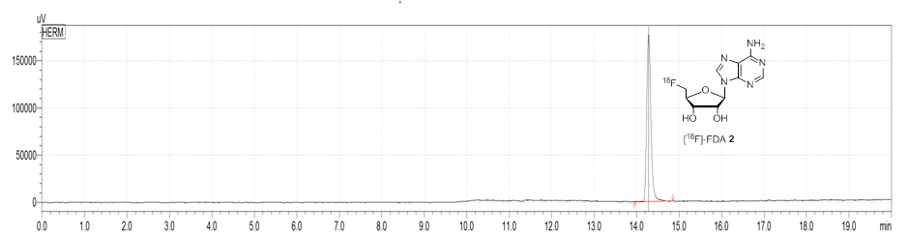
Fig. 2: Radioactivity HPLC chromatogram of [¹⁸F]FDA 2 (14.3 min) after a 30 min incubation of SAM-Cl and [¹⁸F]fluoride with fluorinase/AAO.

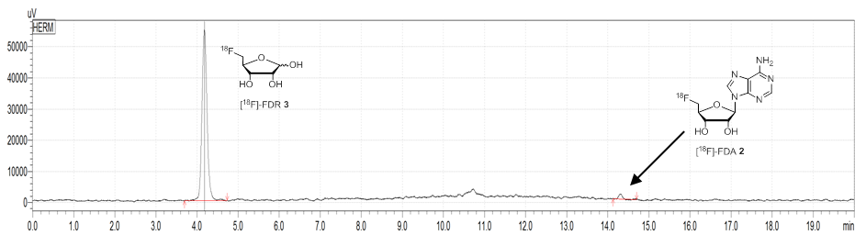
Fig. 3: Radioactivity HPLC chromatogram showing the conversion of [¹⁸F]FDA 2 to [¹⁸F]FDR 3, after 1h, by the action of the nucleoside hydrolase.

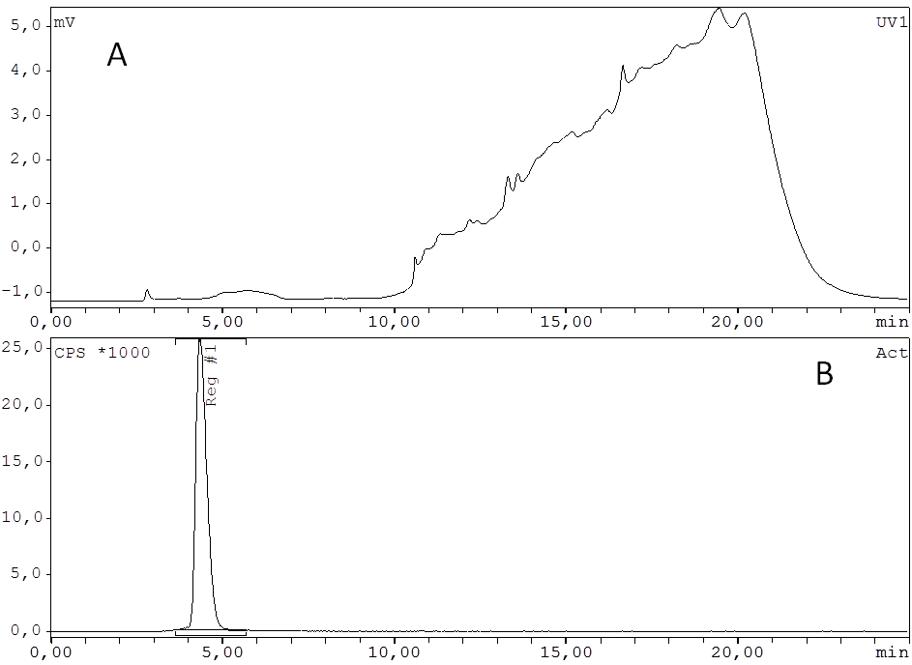
Fig. 4: (A) a UV profile and (B) the radioactivity detector chromatogram of purified [¹⁸F]FDR 3 before mice injections.

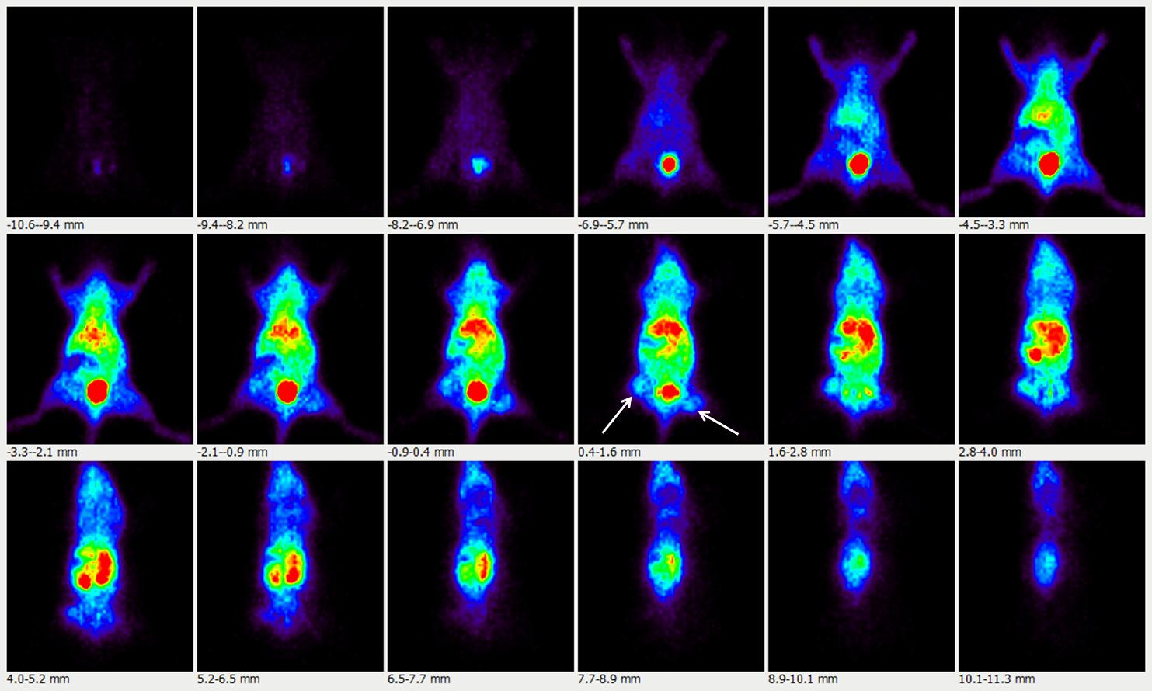
A

B
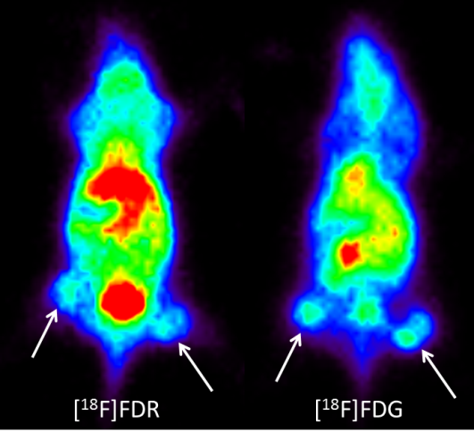

Fig. 5A Whole body distribution summed images (0-20 min) of [¹⁸F]FDR 3.The white arrows indicate the tumours. Fig 5B Representative summed images (time frames 0-20 min) of the tumours (A431human epithelial carcinoma) for [¹⁸F]FDR3 (left panel) and [¹⁸F]FDG (right panel). Images are scaled to the same colouring range. Tumours are indicated by the white arrow.

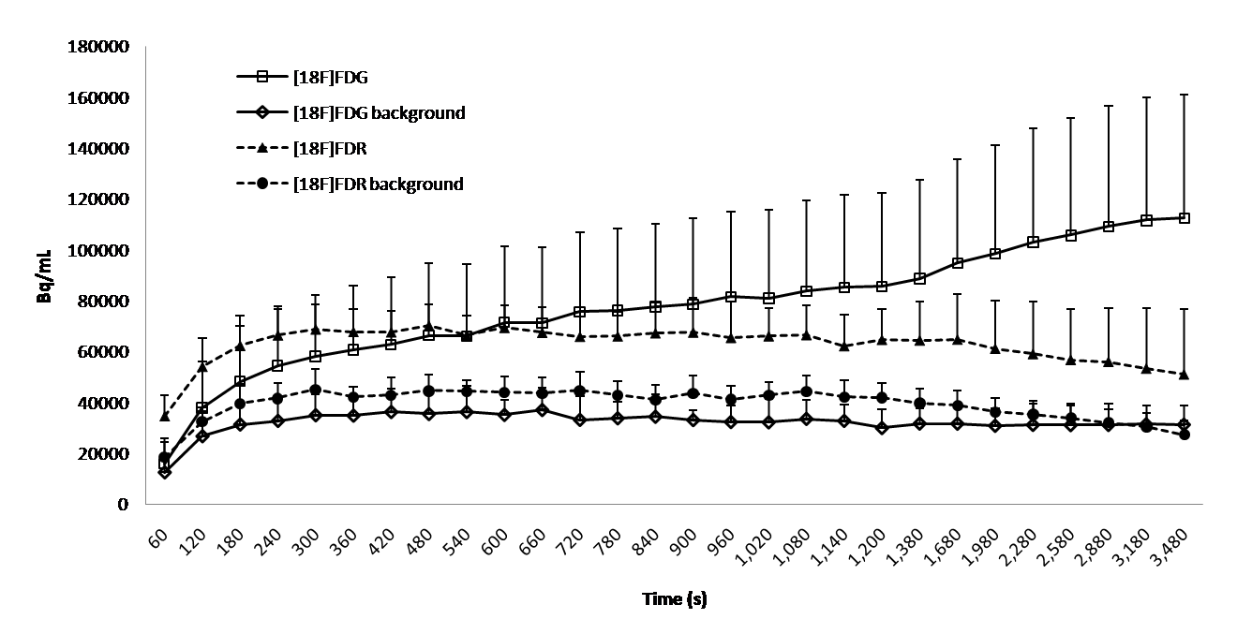
Fig. 6: Time activity curves (+ standard deviation) of the uptake of radiotracers [¹⁸F]FDG and [¹⁸F]FDR 3, averaged over all tumours. In addition the background uptake is shown for both experiments.

